PROJECT REPORT

INTELLIGENT CUSTOMER HELP DESK WITH SMART DOCUMENT UNDERSTANDING

Internship Under : Smartbridge

Name : TENY TOMEY JOSEPH Email ID :teny.tj1822@saintgits.org
Project ID : IISPS-INT-1261

CONTENTS:

- INTRODUCTION
  - Overview
  - Purpose

- LITERATURE SURVEY
  - Existing new problem
  - Proposed solution

- THEORETICAL ANALYSIS
  - Block diagram
  - Hardware / Software designing

4. EXPERIMENTAL INVESTIGATIONS

5. FLOWCHART

6. RESULT

7. ADVANYAGES AND DISADVANTAGES

8. APPLICATIONS

9. CONCLUSION

- FUTURE SCOPE

- BIBLIOGRAPHY

- INTRODUCTION

  - Overview

This project “Intelligent Customer Help Desk With Smart Document Understanding” is a web application that combines multiple Watson AI Services (Discovery , Assistant, Cloud function and Node Red). In this project, we learn best practices of combining Watson services, and how they can build interactive information retrieval systems with Discovery and Assistant.

● Project Requirements: IBM Cloud, IBM Watson, IBM Discovery, Node- RED

● Functional Requirements: IBM Cloud

● Technical Requirements: WATSON AI

● Software Requirements: Python, Watson assistant, Watson discovery

● Project Deliverables: Smartinternz Intership

● Project Team: Teny Tomey Joseph

● Project Duration:29 days

  - Purpose:

The typical customer care chatbot can answer simple questions, such as store locations and hours, directions, and maybe even making appointments. When a question falls outside of the scope of the pre-determined question set, the option is typically to tell the customer the question isn’t valid or to offer to speak to a real person.

In this project, there will be another option. If the customer question is about the operation of a device, the application shall pass the question onto Watson Discovery Service, which has been pre-loaded with the device’s owners manual. So now, instead of “Would you like to speak to a customer representative?” we can return relevant sections of the owners manual to help solve our customers’ problems.

To take it a step further, the project shall use the Smart Document Understanding feature of Watson Discovery to train it on what text in the owners manual is important and what is not. This will improve the answers returned from the queries.

Scope of Work:

- Create a customer care dialog skill in Watson Assistant
- Use Smart Document Understanding to build an enhanced Watson Discovery collection
- Create an IBM Cloud Functions web action that allows Watson Assistant to post queries to Watson Discovery.
- Build a web application with integration to all these services & deploy the same on IBM Cloud Platform
LITERATURE SURVEY

  - Existing Problem

The typical customer care chatbot can answer simple questions, such as store locations and hours, directions, and maybe even making appointments. When a question falls outside of the scope of the predetermined question set, the option is typically to tell the customer the question isn’t valid or offer to speak to a real person.

  - Proposed Solution

Therefore, in order to solve the existing problem statement, we are going to develop a smart chatbot which answers most of the queries of the customer. This is done by incorporating the Watson AI services. Another benefit is that this can work for 24 hours which a normal human being cannot.

Steps:

  - IBM Cloud services
  - Configure Watson Discovery
  - Create IBM Cloud Functions action.
  - Create a Node red flow to connect all the services together.
  - Configure Watson Assistant.
  - Create flow and configure node
  - Deploy and run Node Red app.

3.THEORETICAL ANALYSIS

3.1 BLOCK DIAGRAM

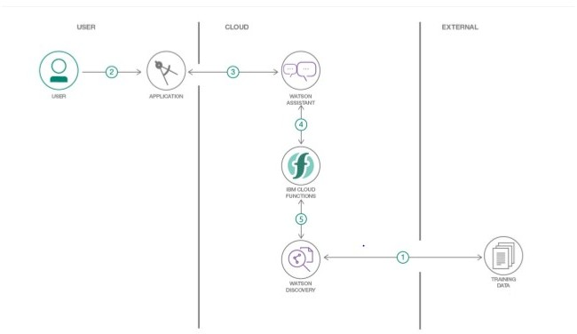

3.2 HARDWARE / SOFTWARE DESIGNING

1.Create IBM Cloud services

Create the following services:
Watson Discovery
Watson Assistant
Node Red

2.Configure Watson Discovery

Import the document
Launch the Watson Discovery tool and create a new data collection by selecting the Upload your own data option. Give the data collection a unique name like owners-manual. When prompted, select and upload your user guide manual for eg: Ecobee3 User Guide file .

Annotate with SDU
Now let's apply SDU to our document to see if we can generate some better query responses. From the Discovery collection panel, click the Configure data button (located in the top right corner) to start the SDU process. The goal is to annotate all of the pages in the document so Discovery can learn what text is important, and what text can be ignored by splitting and colouring the file into titles, subtitiles, text, table of contents, footers, ..etc

3.Create IBM Cloud Functions action

Now let's create the web action that will make queries against our Discovery collection.
Start the IBM Cloud Functions service by selecting Create Resource from the IBM Cloud dashboard. Enter functions as the filter, then select the Functions card:
From the Functions main panel, click on the Actions tab. Then click on Create. From the Create panel, select the Create Action option.
On the Create Action panel, provide a unique Action Name for eg: assistantenhanced, keep the default package and select the Node.js 10 runtime.
Click the Create button to create the action.
Once your action is created, click on the Code tab:
In the code editor window, cut and paste in the code from the disco-action.js file found in the action’s directory of your local repository. The code is pretty straight-forward - it simply connects to the Discovery service, makes a query against the collection, then returns the response.

If you press the Invoke button, it will fail due to credentials not being defined yet. We'll do this next.
Select the Parameters tab:
Add the following parameters:
url
environment_id
collection_id
configuration_id
iam_apikey

For values, please use the values associated with the Discovery service you created in the previous step. Now that the credentials are set, return to the Code panel and press the Invoke button again. Now you should see actual results returned from the Discovery service:
Next, go to the Endpoints panel:
Click the checkbox for Enable as Web Action. This will generate a public endpoint URL.
Take note of the URL value, as this will be needed by Watson Assistant in a future step.
To verify you have entered the correct Discovery parameters, execute the provided curl command. If it fails, re-check your parameter values.

4.Configure Watson Assistant

Launch the Watson Assistant tool and create a new dialog skill. Select the Use sample skill option as your starting point and import the Customer Care Sample Skill . This dialog skill contains all of the nodes needed to have a typical call center conversation with a user. Otherwise, you can create a skill called Customer Care Smaple Skill - Demo and then create all the intents.

Add new intent
The default customer care dialog does not have a way to deal with any questions involving outside resources, so we will need to add this. Create a new intent that can detect when the user is asking about operating the Product. From the Customer Care Sample Skill panel, select the Intents tab.
Click the Create intent button. Name the intent #Product_Information, and at a minimum, enter the following example questions to be associated with it.

Create new dialog node
Now we need to add a node to handle our intent. Click on the Dialog tab, then click on the drop-down menu for the Small Talk node, and select the Add node below option.
Name the node "Ask about product" and assign it our new intent. This means that if Watson Assistant recognizes a user input such as "how do I set the time?", it will direct the conversation to this node.

Enable webhook from Assistant
Set up access to our Webhook for the IBM Cloud Functions action you created in Step #4.
Select the Options tab:
Enter the public URL endpoint for your action. Return to the Dialog tab, and click on the Ask about product node. From the details panel for the node, click on Customize, and enable Webhooks for this node: Click Apply.
The dialog node should have a Return variable set automatically to $webhook_result_1. This is the variable name you can use to access the result from the Discovery service query.

Test in Assistant Tooling
From the Dialog panel, click the Try it button located at the top right side of the panel. Enter some user input: Note that the input "how do I turn on the heater?" has triggered our Ask about product dialog node, which is indicated by the #Product_Information response. And because we specified that $webhook_result_1.passages be the response, that value is displayed also. You can also verify that the call was successfully completed by clicking on the Manage Context button at the top right. The response from the Discovery query will be stored in the $webhook_result_1 variable.

5.Create flow and configure node:
At first go to manage palette and install Dashboard.
Now, create the flow with the help of the following nodes:
Inject
Assistant
Debug
Function
Form
Text

6.Deploy and run Node Red app.

Deploy the Node Red flow.
Then copy the Node-RED link url upto .net and paste at a new tab with /ui at the end of the url, like this,
https://node-red-......mybluemix.net/ui

4.EXPERIMENTAL INVESTIGATIONS

IBM Cloud Dashboard

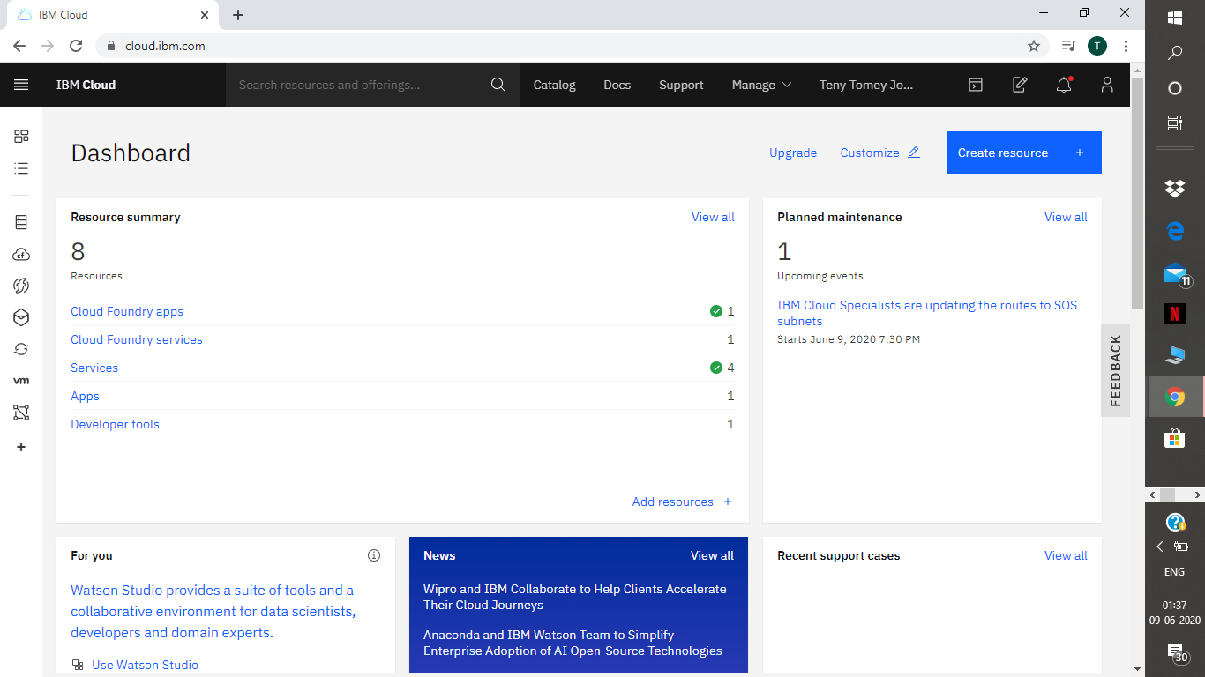

Watson Discovery

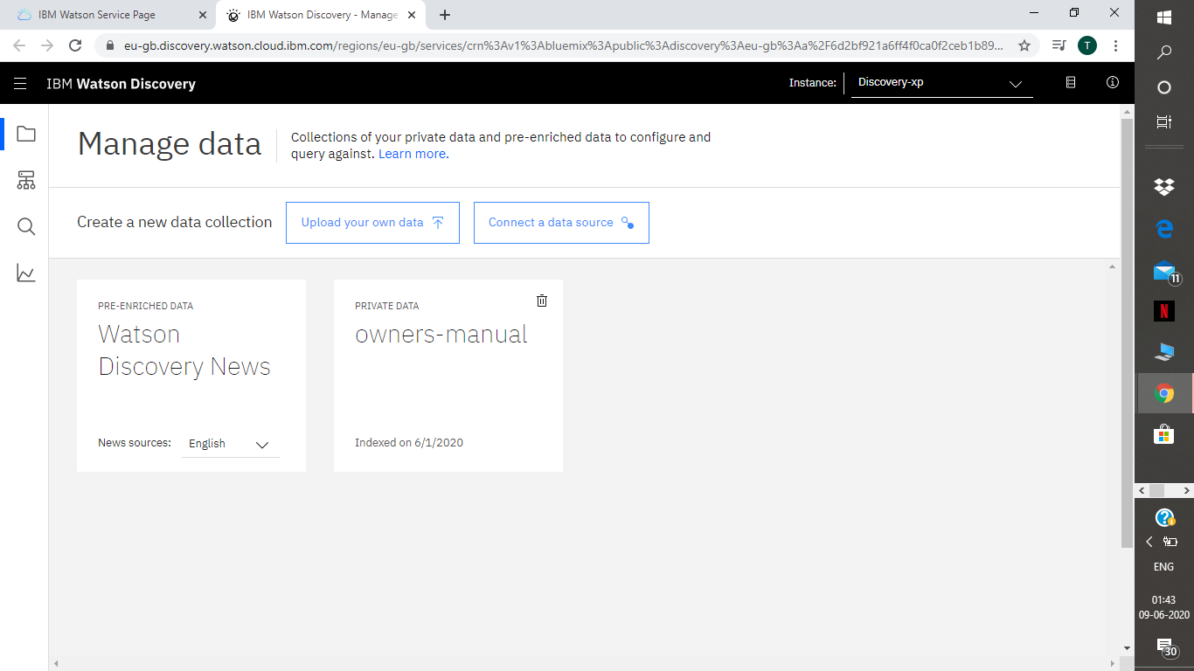
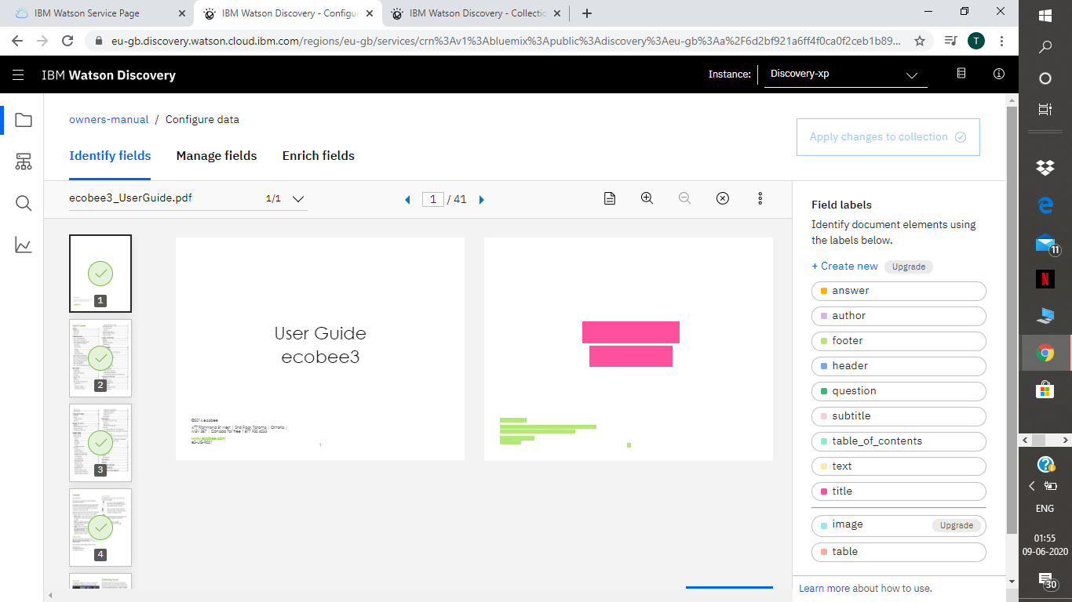

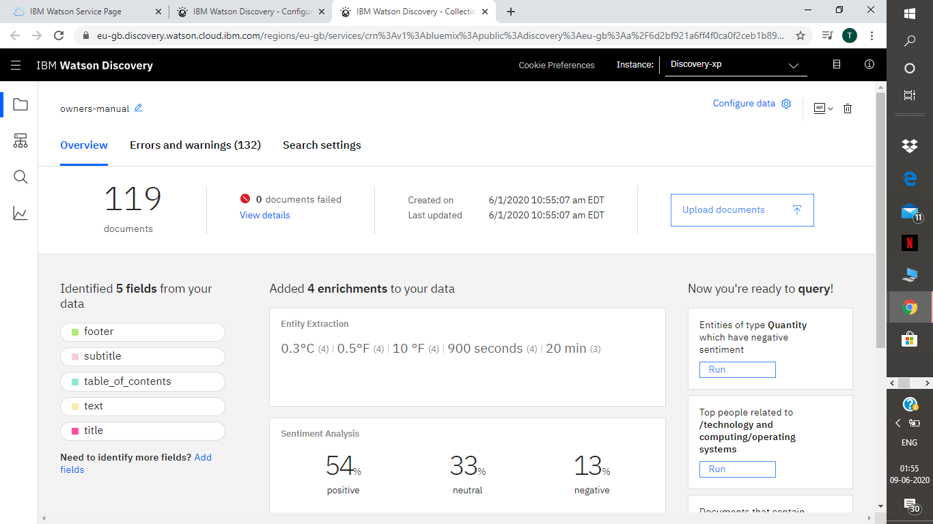

Watson Assistant

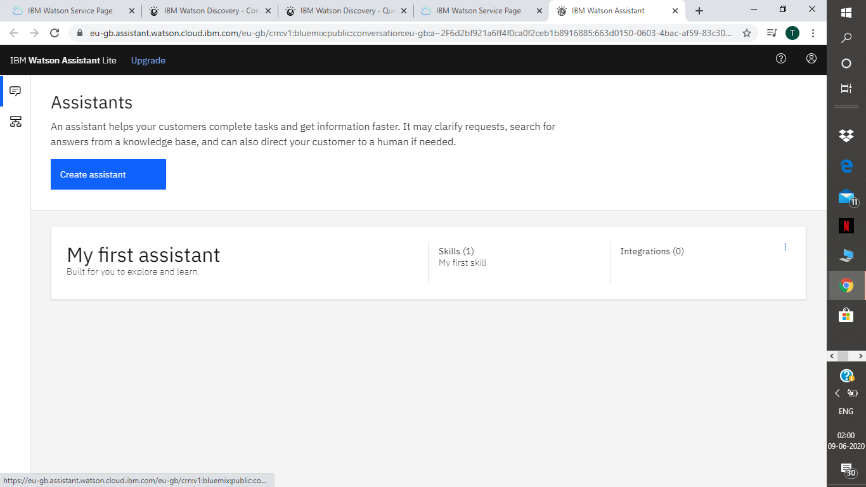

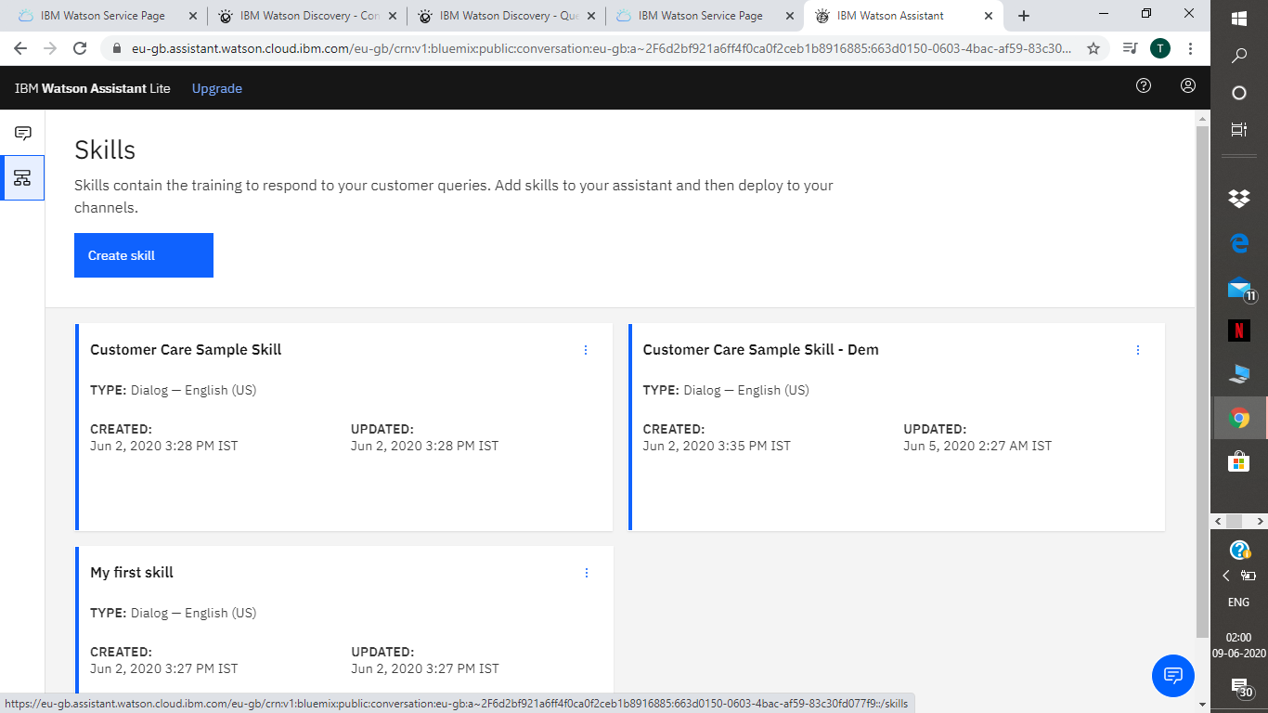

Intents
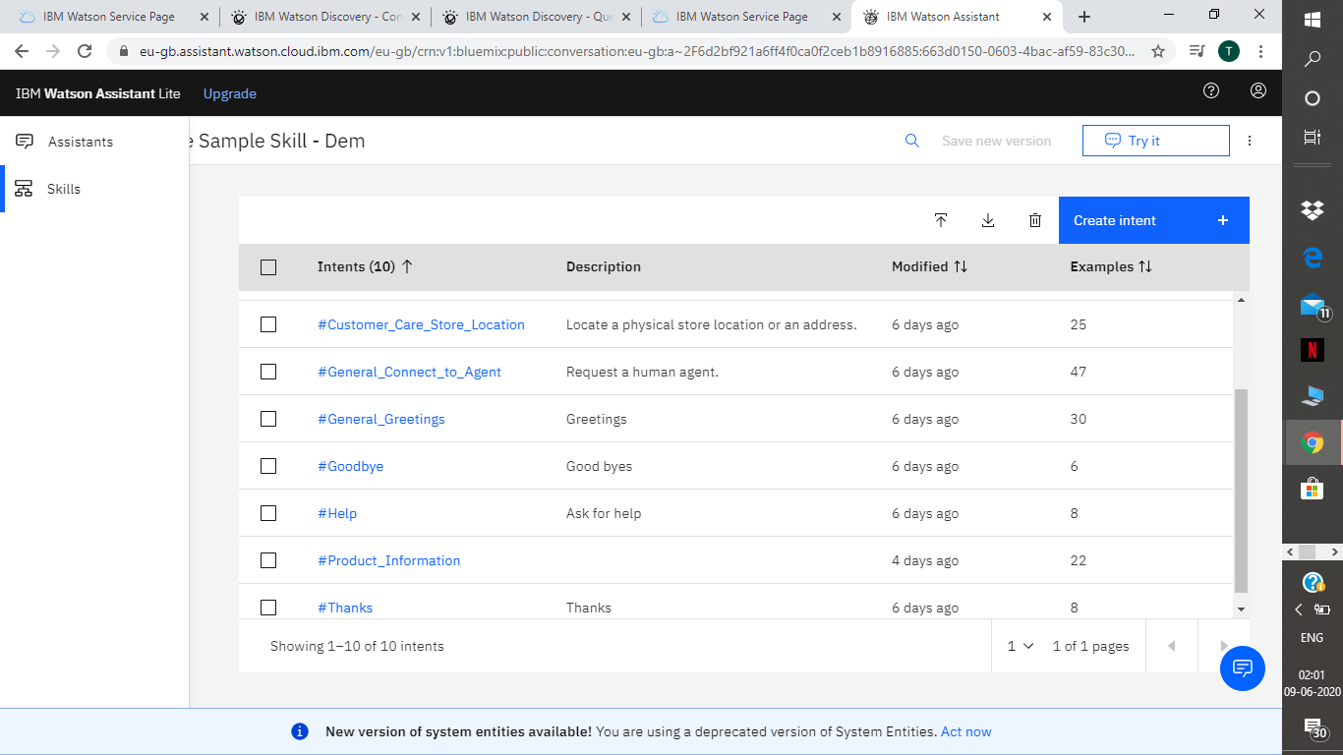

Dialog
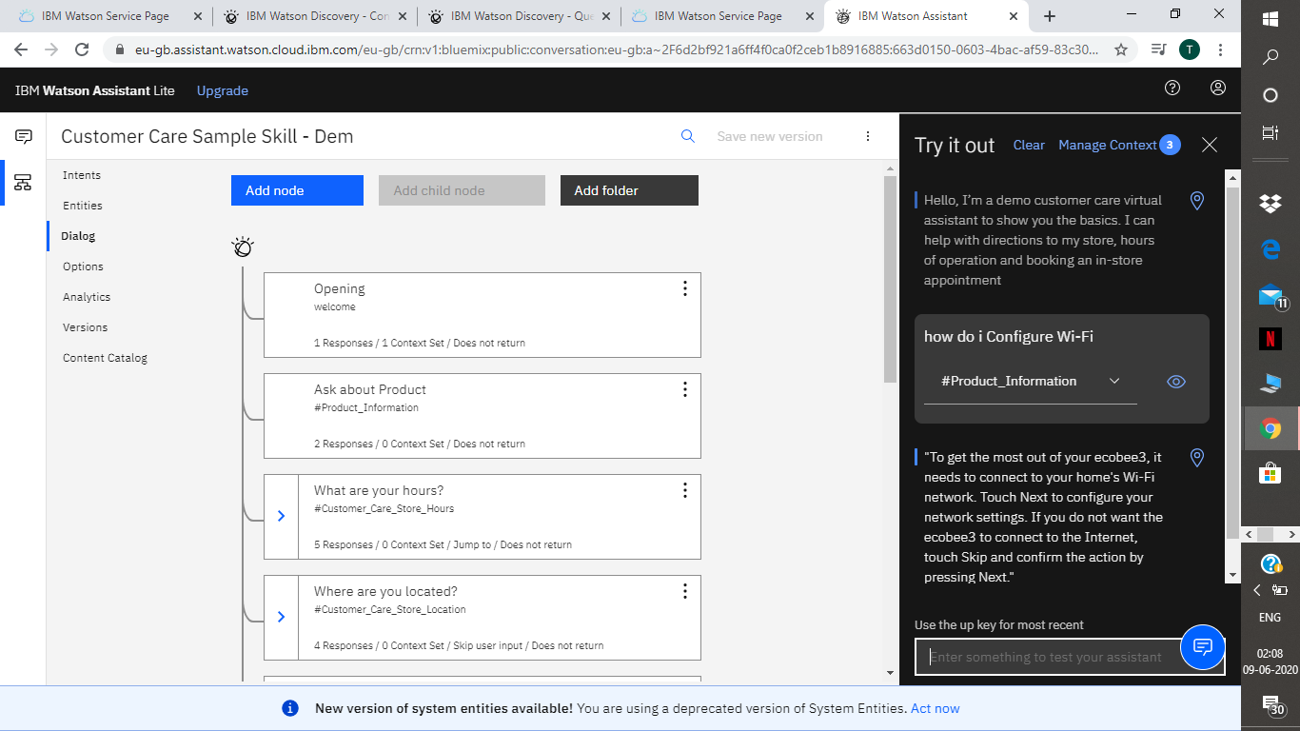

Cloud Function

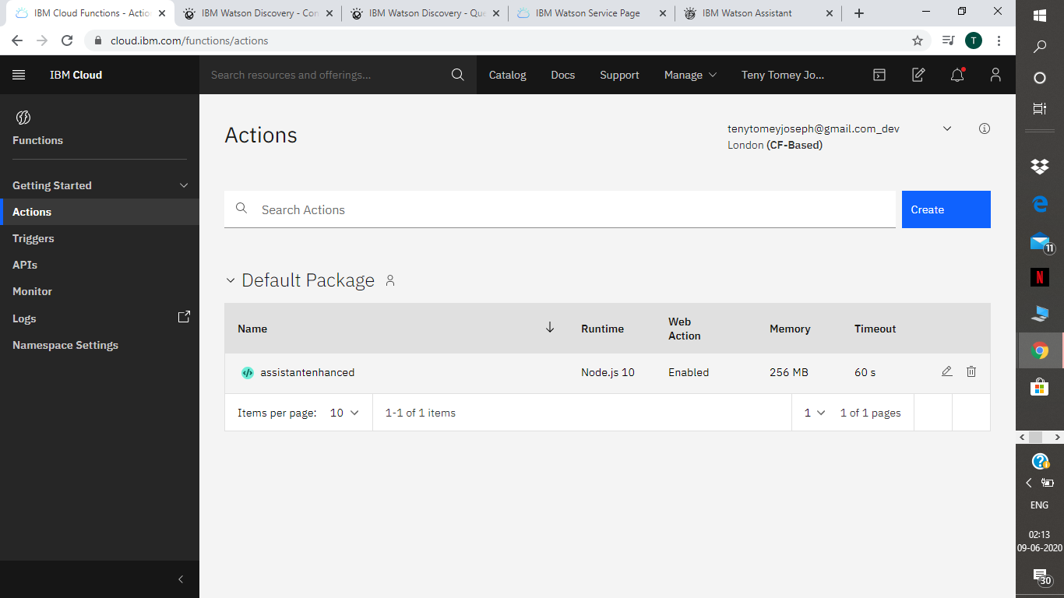

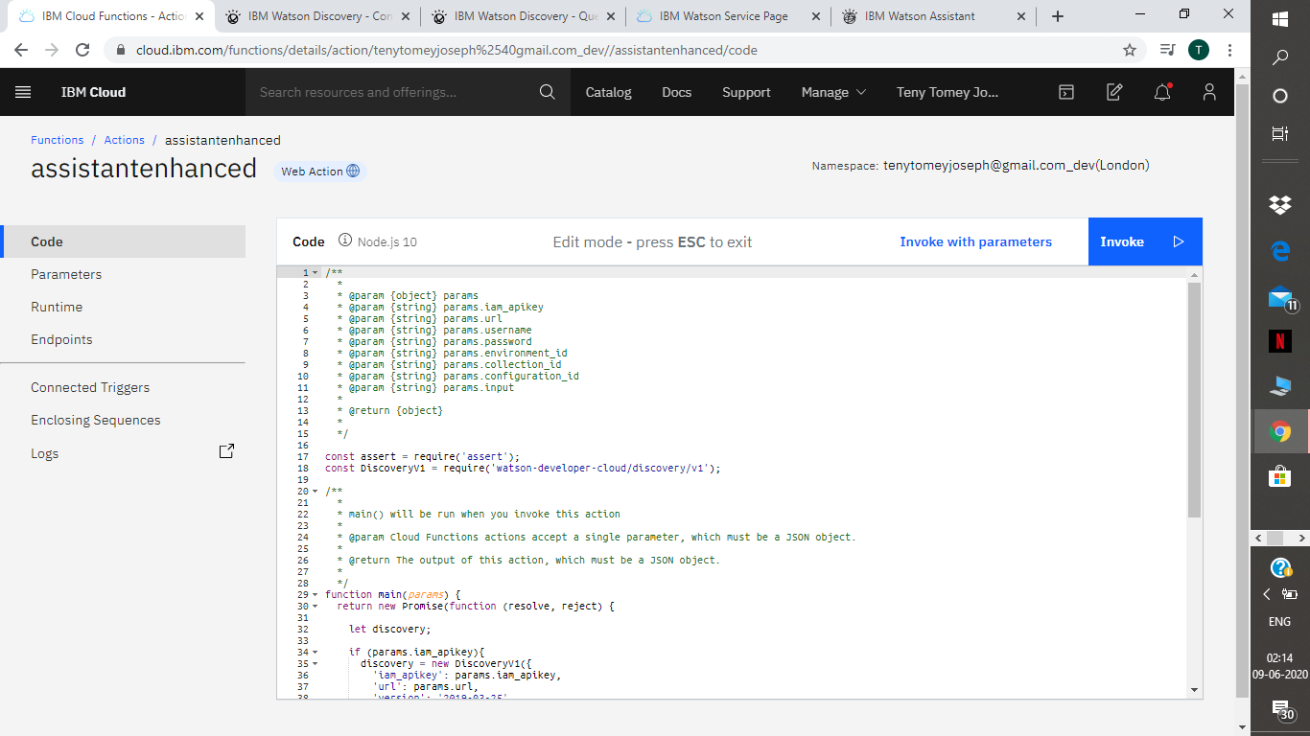

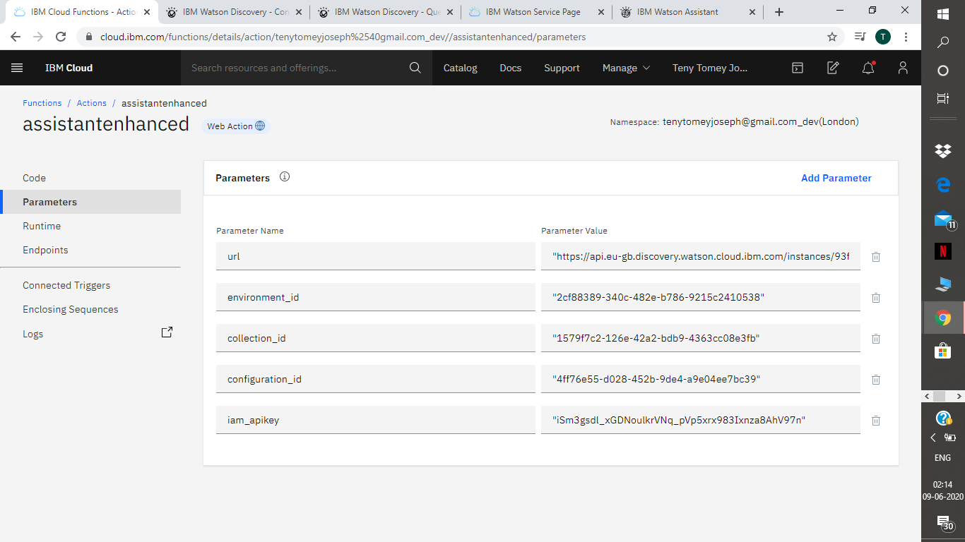

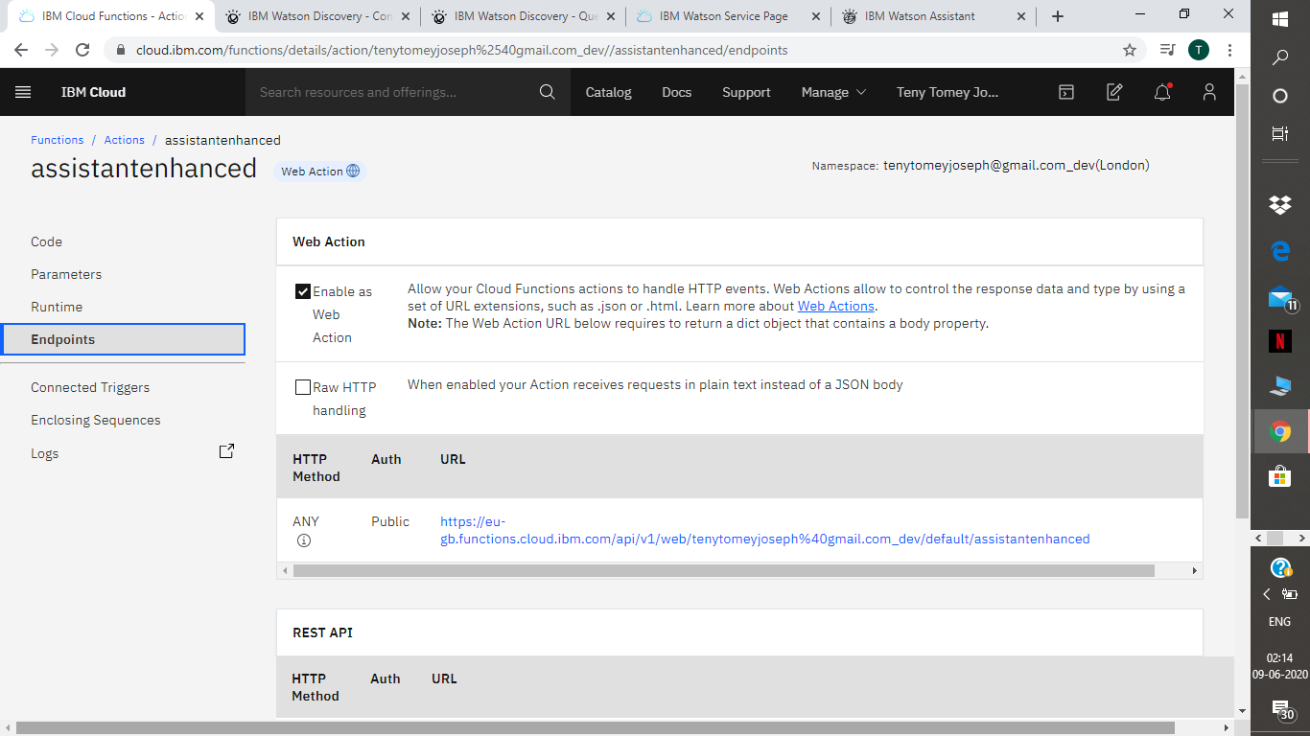

Node-RED

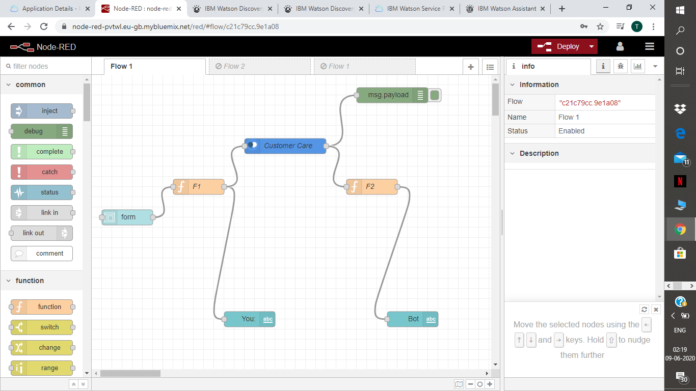

- RESULTS

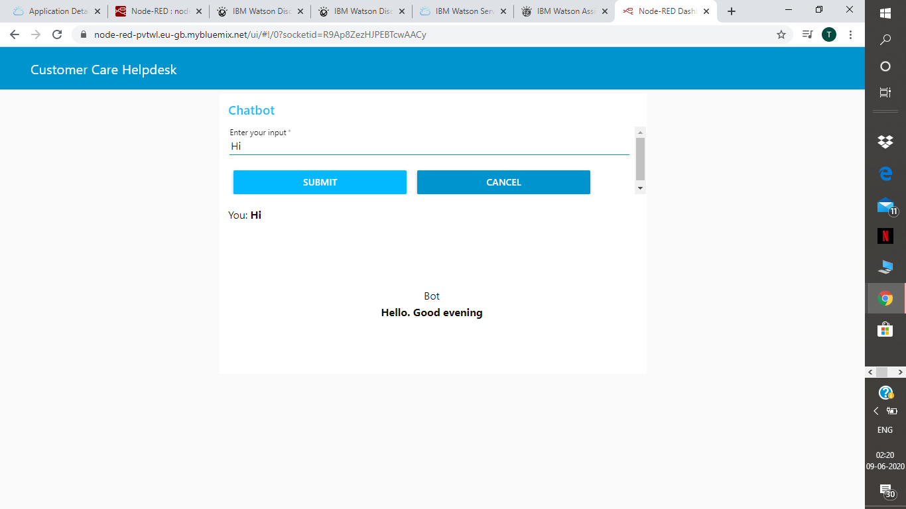

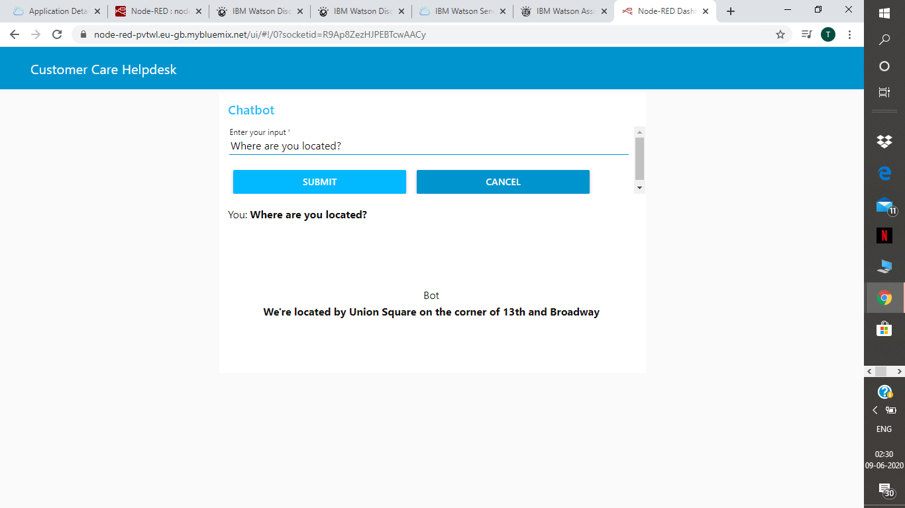

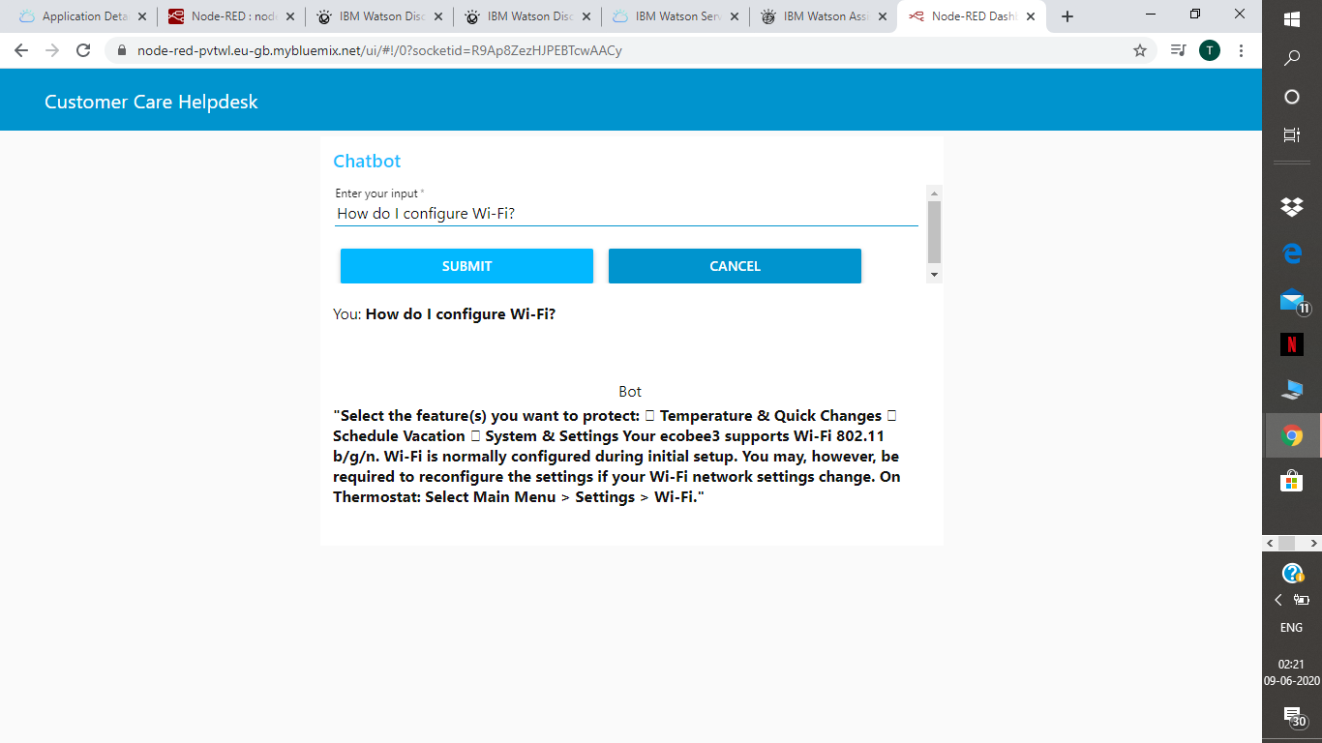

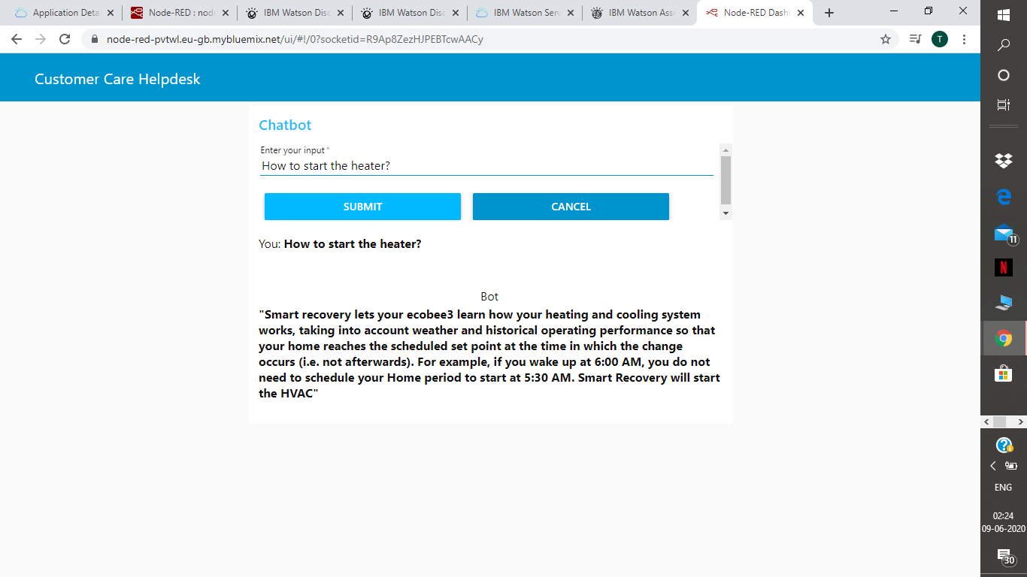

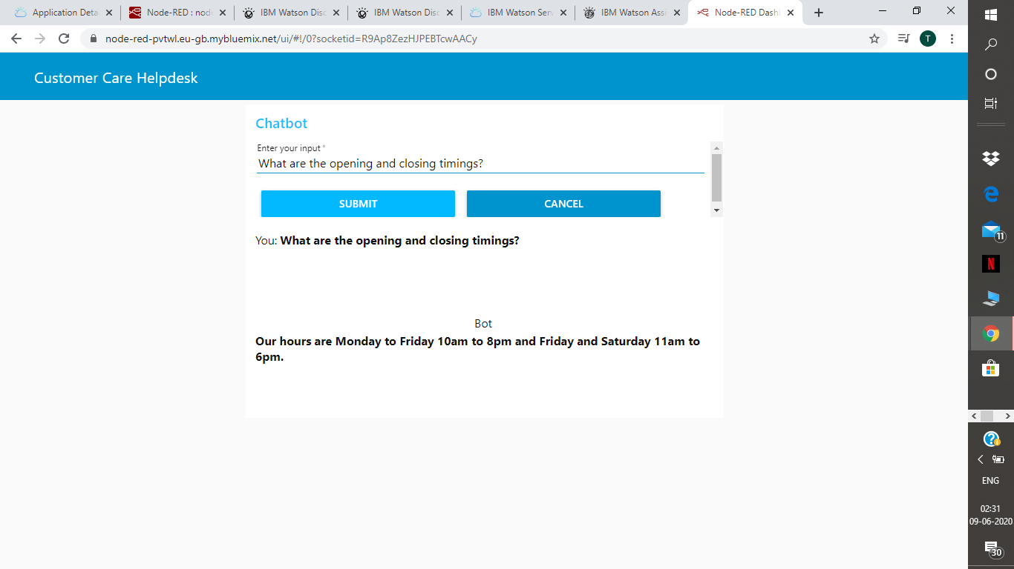

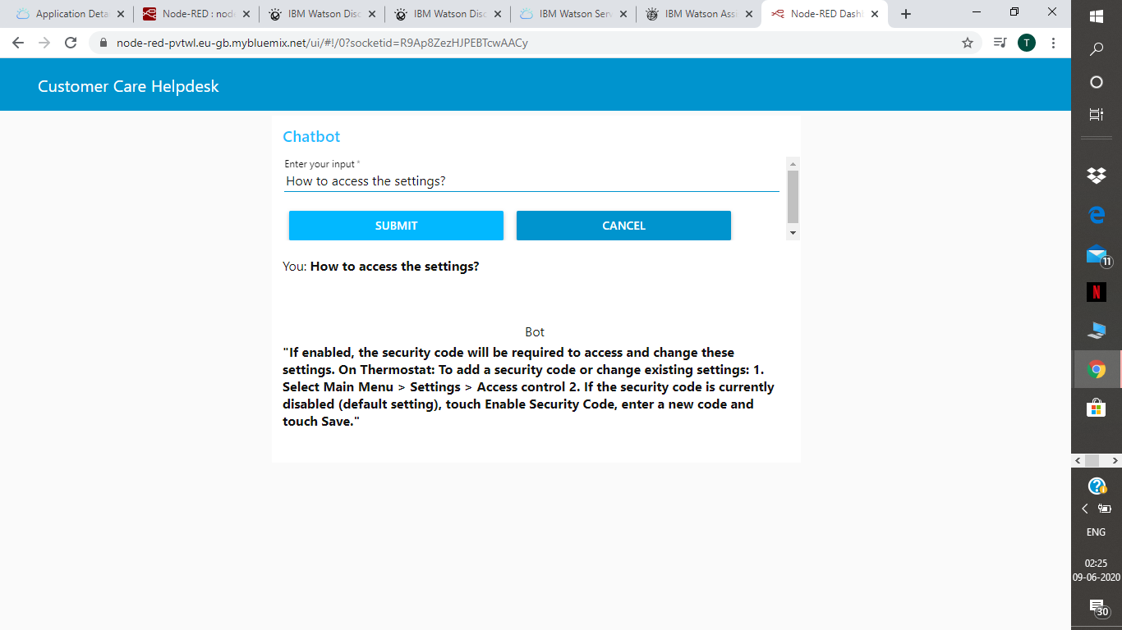

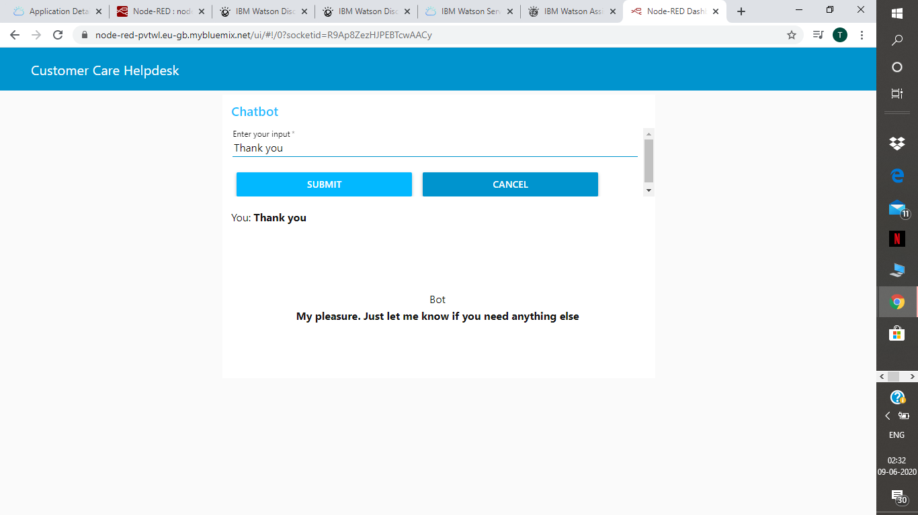

7.ADVANTAGES AND DISADVANTAGES

ADVANTAGES:
- 365X24X7 Support — Unlike your support staff, Chatbots don’t need any breaks, they happily work and learn 24 hours a day. They have a robust cloud architecture.
● Reduce operational and service expense
- Reduces man power
● Get a new age platform to wow your customers
● Increase engagement with customers and touchpoints
● Eliminate mobile app-fatigue
● Multiply reach, increase breadth and depth of engagement
● Rich analytics and customer interaction
● Instantaneous response without the need for human response delays
- Quick learning and updating
- Management of multiple clients
- This type of application is better than the user manuals.

DISADVANTAGES:
- Lack Emotions
● It is very challenging to create a chatbot from scratch. It requires that you invest significant time and effort into creating it. You may also need to have some coding knowledge to create a better-functioning chatbot.
● They have been designed to handle first-level questions only. They may not be able to solve complex queries.
- Sometimes, it may mislead customers as it tries to search irrelevant information in the manual. It may also give same answers to different queries.
● Chatbots require ongoing review, maintenance, and optimization in terms of their knowledge base and the way they are supposed to communicate with our customers.
- Complex interface
- Bad memory : Can’t memorize the conversation it already had,which forces the user to write the same thing again and again.

8.APPLICATIONS

Some applications can be: -
- Help User: This chatbot will be useful for the user to ask the assistant the queries related to the Product and will give them clear guidance about the Product. If the Assistant doesn’t know about a certain query, it will redirect to the correct person for it.

2. Content delivery: Media Publishers have realized that chatbots are a powerful way to engage with their audiences and monitor engagement to gain valuable insights on reader interests. Chat with the CNN and Wall Street Journal Chatbots on Facebook Messenger and receive the latest news directly in Messenger, without having to visit their websites.

3. Companionship: The primary function of the chatbot is to be a virtual companion – To speak with senior people on general topics like the weather, nature, hobbies, movies, music, news, etc. The chatbot asks questions, reacts to the answers, is able to speak on various topics, and share interesting news and facts from Google.

- CONCLUSION

This chatbot will be useful for the user to ask the assistant the queries related to the Product and will give them clear guidance about the product. If the Assistant doesn’t know about a certain query, it will redirect to the correct person for it. Chatbots are quickly making transformational changes and allowing businesses to thrive through customer interactions. The feedback and survey through chatbots strengthen the position of businesses as they analyze the reason behind different levels of customer approval. Use of conversational AI chatbots only means better engagement and relentless need for customer satisfaction in the near future.

- FUTURE SCOPE

Future Scope of this chatbot can be by adding the following to make it more advance: -
1. Smarter Virtual Assistants: Much of what virtual assistants do now are basic skills, such as retrieving data and basic computation. As natural language processing (NLP) continues to mature, virtual assistants will improve their comprehension and response capabilities, allowing for their use to become more widespread and complex. Also, as machine learning progresses, we may see virtual assistants become smarter and begin to learn and predict customer needs.
2. Integration with IoT Devices: Car speakers, smart home devices, and wearables are just a few examples where the virtual assistant is departing from its original hardware and making its way to in-context devices. These integrations ensure that virtual assistants can always be near their human and ready to support any need. It is expected that these integrations will continue at an accelerated pace throughout 2018.
3. Voice-control: Voice recognition can be added with the virtual assistant. Then the customer can control application by using his voice. Soon, we could be joining meetings with a voice command, instead of dialing in the long meeting ID and password.

- BIBLIOGRAPHY

- https://www.ibm.com/cloud/architecture/tutorials/cognitive_discovery
- https://cloud.ibm.com/docs/assistant?topic=assistant-getting-started
- https://developer.ibm.com/recipes/tutorials/how-to-create-a-watson-chatbot-on-nodered/
- https://github.com/IBM/watson-discovery-sdu-with-assistant
- https://developer.ibm.com/tutorials/how-to-create-a-node-red-starter-application/
- https://www.youtube.com/watch?v=hitUOFNne14
- https://www.youtube.com/embed/5z3i5IsBVnk
- https://cloud.ibm.com/docs/openwhisk?topic=cloud-functions-getting-started

